**VIETNAM NATIONAL UNIVERSITY – HO CHI MINH CITY**

**INTERNATIONAL UNIVERSITY**

**(IU-VNU)**

**Object-Oriented Programming**

**(MINI PROJECT)**

**LECTURER: Dr. Lê Thành Sơn**

**LAB LECTURER: Dr. Nguyễn Quang Phú**

*ITDS19IU11a – GROUP 15*

**Prepared by Pham Tran Anh Phuc, Duong Vi Quyen, Nguyen Hoang Duy.**

For internal use only Last revised December 3rd, 2020

**ACADEMIC YEAR : 2020-2021**

**OUR PROJECT**

**BANK MANAGEMENT SYSTEM**

**Introduction:**

IU Bank (Banking Management System) is a mini project application coded in Java programming language built using Netbean. The application can be used for normal banking purposes and this software is mainly used for Admin and User. That is Admin can manage their customer via this app and the User can create an account and use it for their transaction purposes.

**Application’s Function:**

1. **Create an Account:**  
   User can create an account by provide their personal information, the system will evaluate it and also give them a random ID which is unique to identify among customer.
2. **View Profile:**  
   When access to the app, user can view their personal information.
3. **Edit Profile:**  
   They can change their personal information too.
4. **Deposit Money:**  
   By typing the amount of money the user wants to deposit, this money will be added into total balance.
5. **Transfer Money from one account to another:**  
   By typing the amount of money they want to transfer and the ID who will get it, this amount will be transfer to receiver.
6. **Withdraw Money from an account:**  
   By typing the amount of money, the user can withdraw it and this amount also is subtracted into total balance.
7. **View Customer List:**  
   It is a function of admin which is used to view the personal information of all customer.
8. **View Transactions:**  
   It is also a function of admin; they can use it to see all transaction history which is done on this app.
9. **View Balance:**  
   Admin also can view balance of their all customer by typing the customer’s ID.
10. **Search Customer:**  
    By typing the username of customer, Admin can see more detail information about them.
11. **Change Password:**  
    The customer can change their password for better security.
12. **Update money automatically:**

Saving account: app will add interest to customer’s balance each month.

Current account: the over limit will increase each month **(Working)**

**The Login admin username will be “Admin” and the password will be “Admin”.**

The application is also capable of showing various messages by use try-catch structure which include:

1. Login error when your username or password does not match.
2. Incorrect name error when you type the name of the person wrong, whose profile you’re trying to view.
3. Also, when you try to change the pin for your particular account and your pin does not match in your “new pin” and “confirm new pin” field, an error message pops up displaying “Pin does not match”.
4. Also, there are different message pop ups when you’re successful in doing various operations like creating new account, editing profile, depositing money, transferring money, withdrawing money and changing pin.

**Application Requirements:**

1. **Language:** Java.
2. **IDE:** Netbean.
3. **Database:** use SQLite to store data( down DB Browser to view all data).
4. **Jar file:**  
   **JTattoo**: set LookAndFeel for application, make it more beautiful.  
   ***Jcalendar***: use it to choose date.  
   **rs2xml**: populate jtable from database.  
   **sqlitejdbc**: connect SQLite to JDBC in Java.

**Class Diagram:**

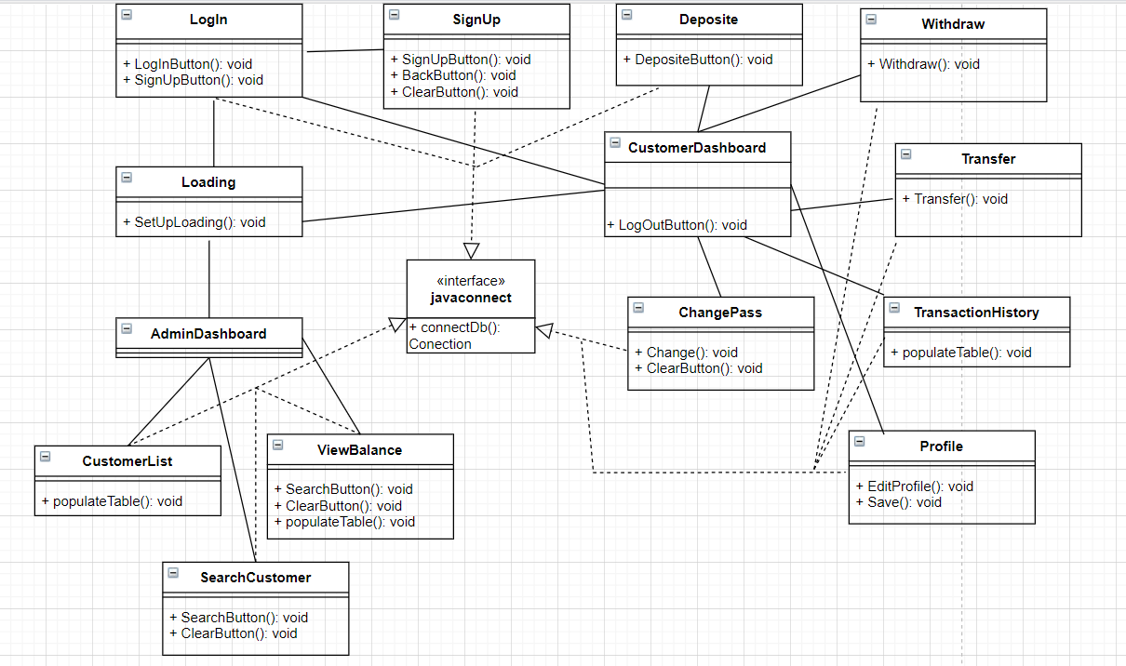

**How to use this app?**

**Case 1:** A customer

Step 1: Run Login.java to open Log In interface and click sign up to create new account.

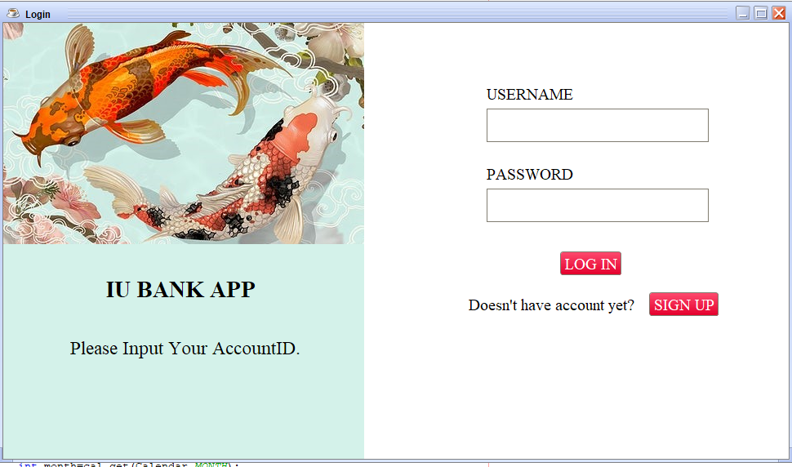

Step 2: The sign up page will appear and input your information (please input all of information) then click sign up and click back to Log in page.

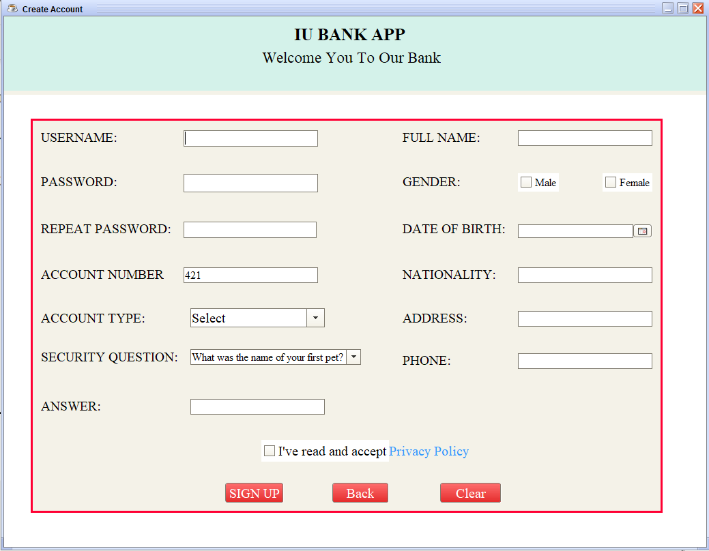

Step 3: Input username, password and wait app for processing.

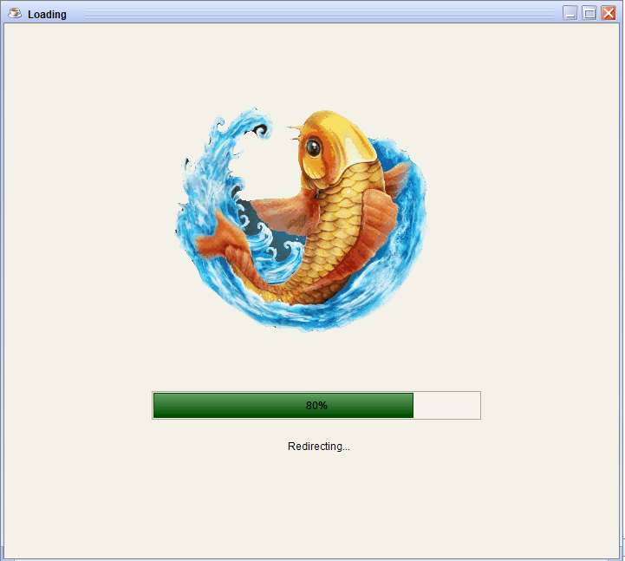

Step 4: Customer Dashboard will appear and we can use some functions such as: deposit, withdrawn, transfer money.

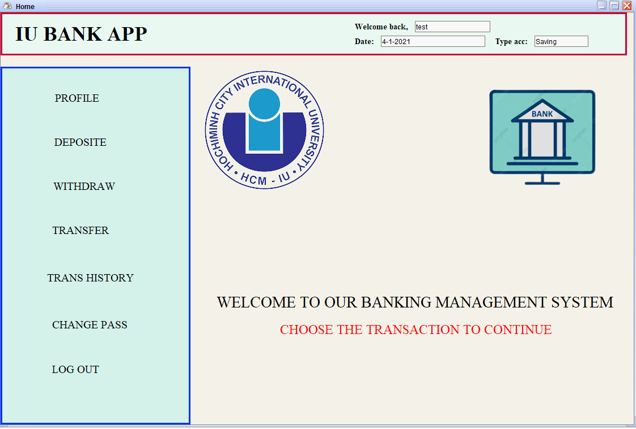

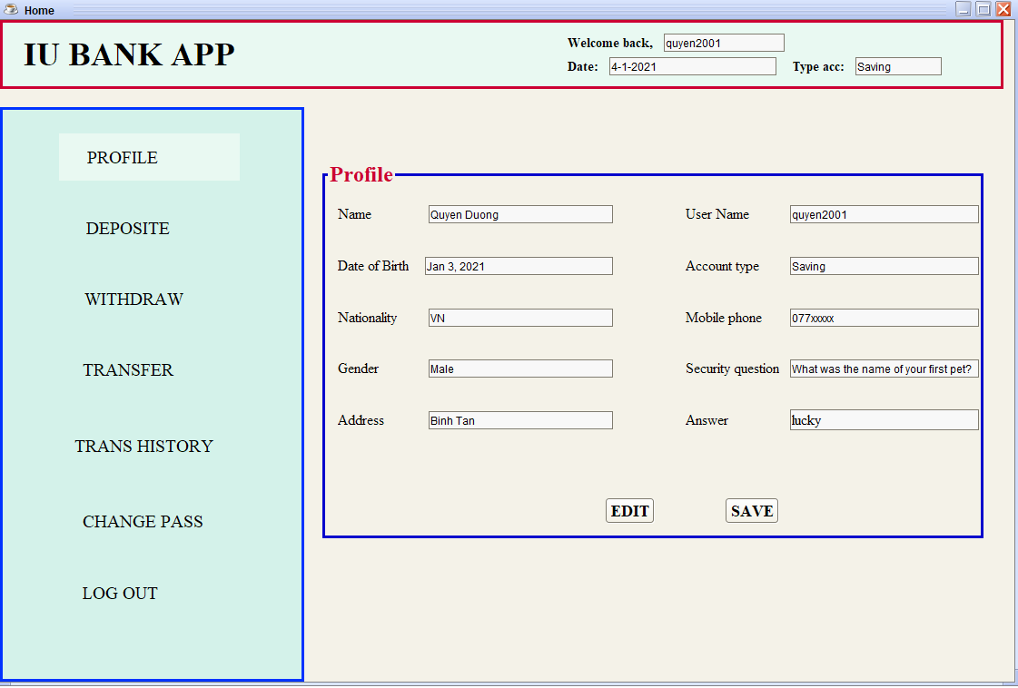

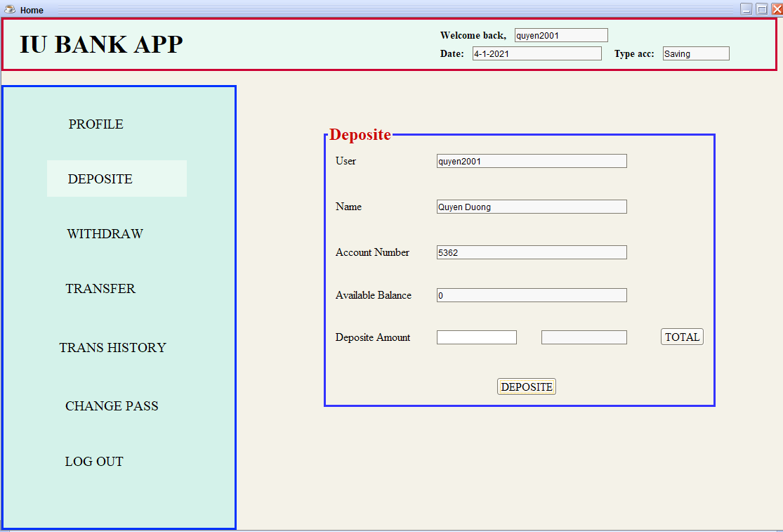

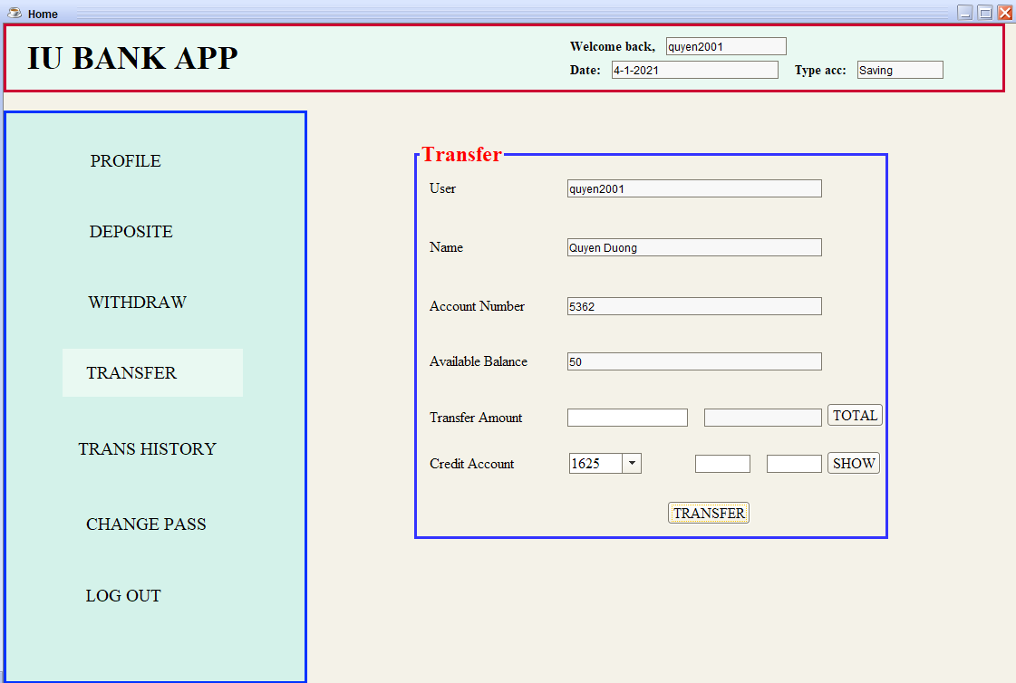

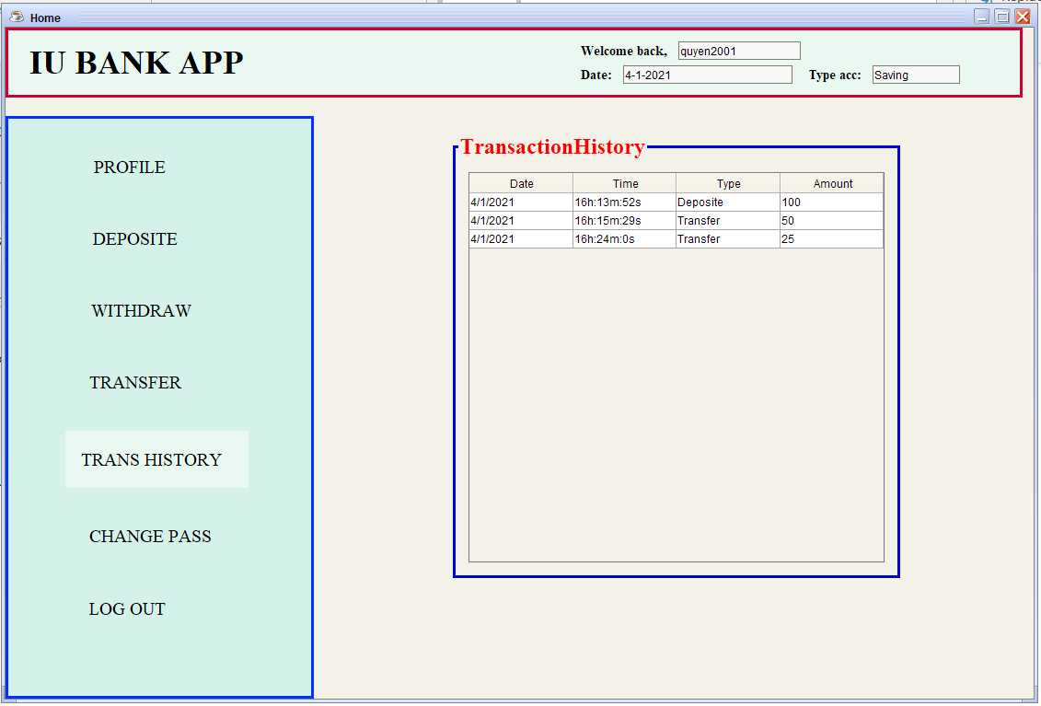

**Case 2:** An administrator

Step 1: Input Username “**Admin**” and Password “**Admin**” in log in page.

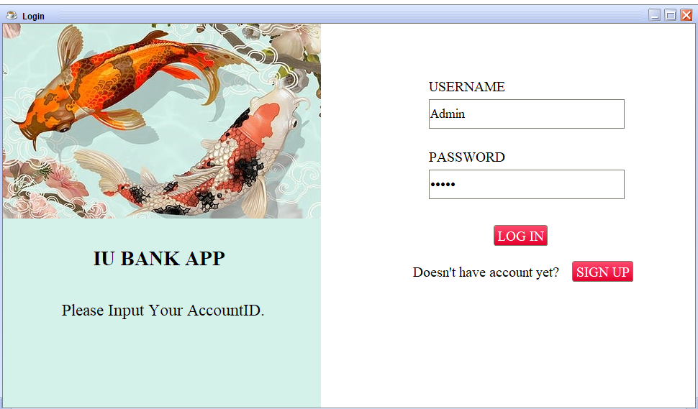

Step 2: Now we can access to Admin Dashboard. In here, we can view customer list, profile, balance and transaction history of each account.

